**Muhammad Abdullah**

**SE(6A) | 19F-0916**

Computer Networks Lab 8

VLSM by Dynamically Routing

**TASK 1**

Step 1: Using 4 Routers

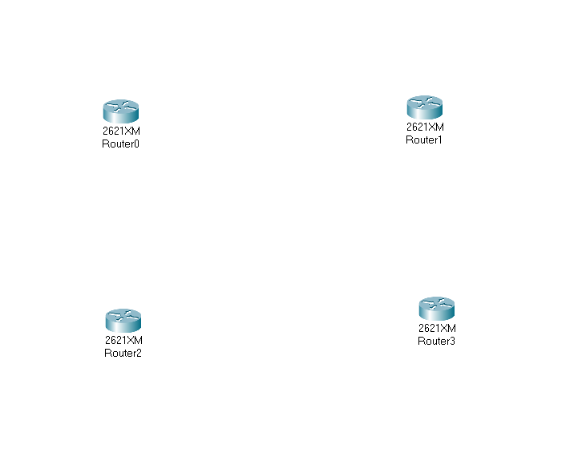

Step 2: Using 5 Switches

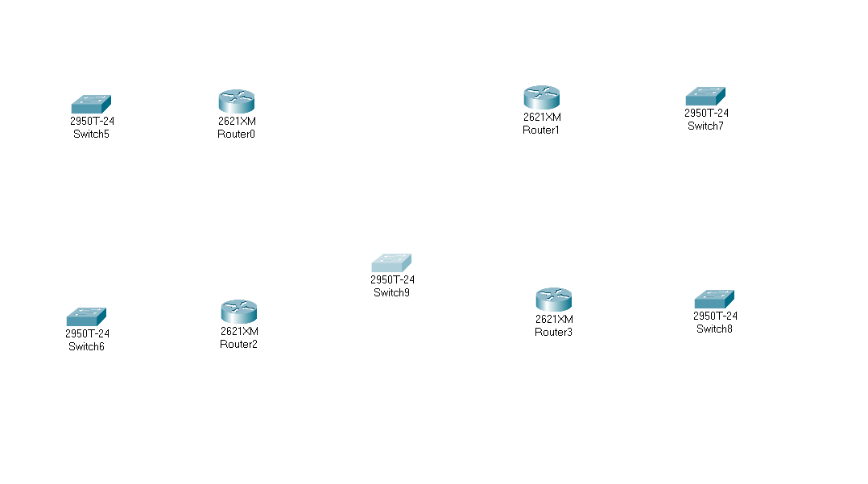

Step 3: Configuration of Router to enable Serial Port in 1st Router.

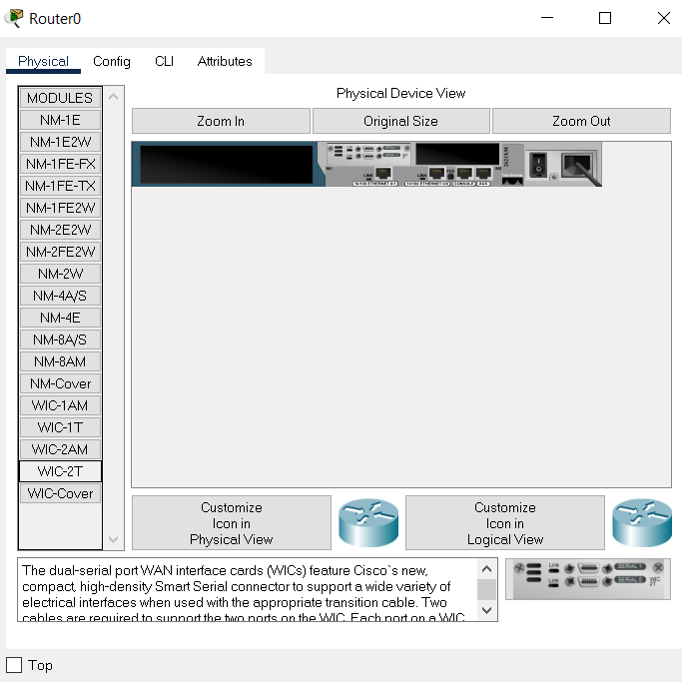

Step 4: Configuration of Router to enable Serial Port in 4th Router.

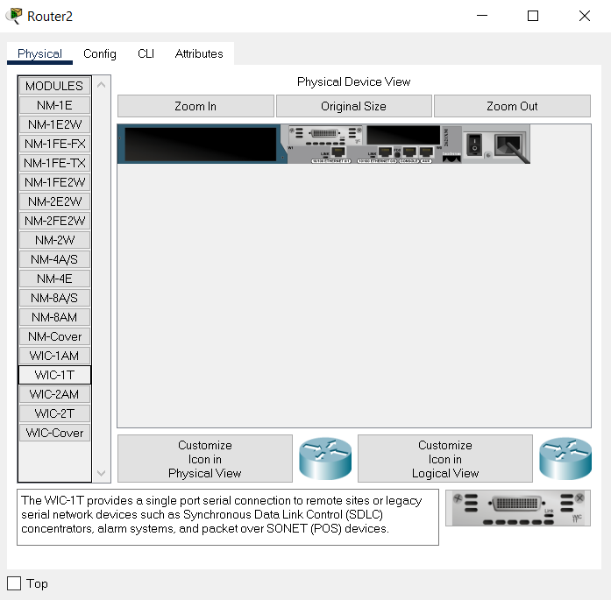

Step 5: Connecting all routers with switches and Computers

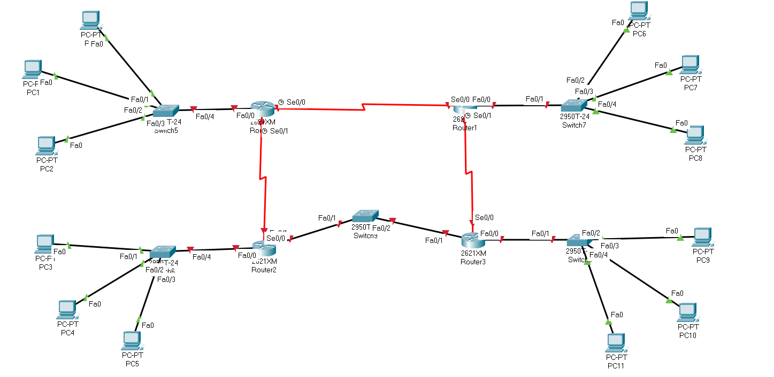

Now, we need to configure the Router’s and PC’s IP Addresses.

This is done in Dynamically Order and Pictures are attached below:

Step 6: Configuration of 1st Router by CLI Mode:

Step 7: Configuration of Computer connected with 1st Router by DHCP:

Step 8: Configuration of 2nd Router by CLI Mode:

Step 9: Configuration of Computer connected with 2nd Router by DHCP:

Step 10: Configuration of 3rd Router by CLI Mode:

Step 11: Configuration of Computer connected with 3rd Router by DHCP:

Step 12: Configuration of 4th Router by CLI Mode:

Step 13: Configuration of Computer connected with 4th Router by DHCP:

Step 14: OSPF Configuration of 1st Router With 2nd Router

1st Router Configuration:

2nd Router Configuration:

After this, now both can communicate with each other/and send message packages to each other.

Step 15: OSPF Configuration of 2nd Router With 3rd Router

2nd Router Configuration:

3rd Router Configuration:

After this, now both can communicate with each other/and send message packages to each other.

The same is the case for the 1st Router with the 4th Router as shown in the topology. After these steps, all connections are built with each other and now end devices can send data over the established link. Final Topology and Message sending screenshots are attached below.

Step 17: Sending Message in Final Topology from Network’s 1 Pc to Network’s 2 Pc:

